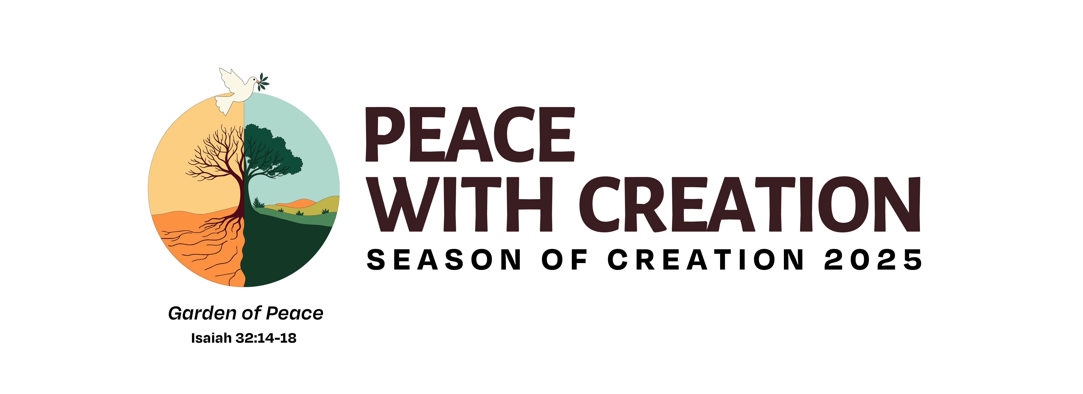
How Can Your Congregation Participate in the Season of Creation?
September 1 – October 5

The Season of Creation is a time for Christians to come together in prayer and action for the healing of Creation. It is celebrated throughout the world not only by Protestant denominations but also in the Roman Catholic and Greek Orthodox Communions, where it originated
.
General Resources: https://seasonofcreation.org/resources/

Worship Resources: ECUSA website at: https://newcreationliturgies.org/seasonofcreation/ Bishop Mello has authorized the use of these liturgies for Sunday worship.

Daily Devotions: Praying with Creation Ready-to-go Info for your Newsletter below:
New Daily Devotions for the 2025 Season of Creation - delivered to you by email:
Why these Devotions? Most of us know very little about the great web of life that surrounds us. The purpose of these daily devotions is to open our eyes to some of the “created ones” with whom we share common ground, to awaken our hearts to their needs, and to take new steps toward living together in peace.
Each day of the Season of Creation (September 1 - October 4) participants will receive an email which highlights a different species in our Province 1 Ecosystems. Each email will include a photo, a brief description of the species for the day, a few thoughts on how the species reflects our image of God, and a closing prayer.
Sample Daily Devotion: https://conta.cc/4kdEy7j

Sign-up Link;
https://lp.constantcontactpages.com/sl/IhYGn6v/PrayingWithCreation2025
The Devotions will also be accessible at the website of An Episcopal Path to Creation Justice website: https://www.episcopalcreationpath.org

